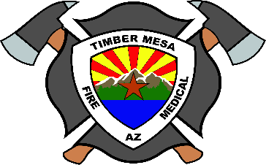

TIMBER MESA FIRE AND MEDICAL DISTRICT
Board Posting

Pursuant to ARS 38-431.02, notice is hereby given to the Timber Mesa Fire and Medical District Fire Board and to the general public that Timber Mesa Fire and Medical District board members will be attending an appreciation lunch at 3156 E Deuce of Clubs in Show Low, Arizona on Monday, March 23, 2026.

No Timber Mesa Fire and Medical District business will be discussed, and no legal action will be proposed or taken at this event.

